第十四章 运行流程图解

流程图
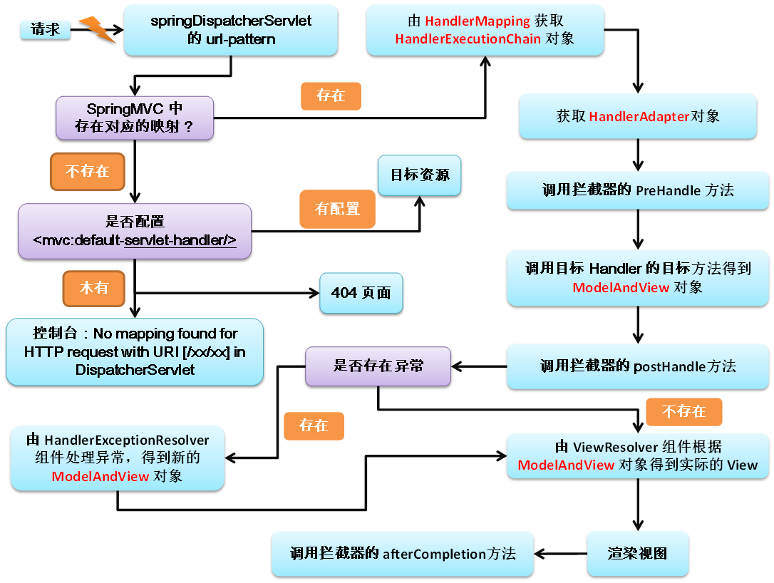

Spring工作流程描述
- 用户向服务器发送请求，请求被SpringMVC 前端控制器 DispatcherServlet捕获；
- DispatcherServlet对请求URL进行解析，得到请求资源标识符（URI）:
判断请求URI对应的映射
  - 不存在：
    - 再判断是否配置了mvc:default-servlet-handler：
    - 如果没配置，则控制台报映射查找不到，客户端展示404错误
    - 如果有配置，则执行目标资源（一般为静态资源，如：JSP,HTML）
  - 存在：
    - 执行下面流程
- 根据该URI，调用HandlerMapping获得该Handler配置的所有相关的对象（包括Handler对象以及Handler对象对应的拦截器），最后以HandlerExecutionChain对象的形式返回；
- DispatcherServlet 根据获得的Handler，选择一个合适的HandlerAdapter。
- 如果成功获得HandlerAdapter后，此时将开始执行拦截器的preHandler(...)方法【正向】
- 提取Request中的模型数据，填充Handler入参，开始执行Handler（Controller)方法，处理请求。在填充Handler的入参过程中，根据你的配置，Spring将帮你做一些额外的工作：
  - HttpMessageConveter： 将请求消息（如Json、xml等数据）转换成一个对象，将对象转换为指定的响应信息
  - 数据转换：对请求消息进行数据转换。如String转换成Integer、Double等
  - 数据根式化：对请求消息进行数据格式化。 如将字符串转换成格式化数字或格式化日期等
  - 数据验证： 验证数据的有效性（长度、格式等），验证结果存储到BindingResult或Error中
- Handler执行完成后，向DispatcherServlet 返回一个ModelAndView对象；
- 此时将开始执行拦截器的postHandle(...)方法【逆向】
- 根据返回的ModelAndView（此时会判断是否存在异常：如果存在异常，则执行HandlerExceptionResolver进行异常处理）选择一个适合的ViewResolver（必须是已经注册到Spring容器中的ViewResolver)返回给DispatcherServlet，根据Model和View，来渲染视图
- 在返回给客户端时需要执行拦截器的AfterCompletion方法【逆向】
- 将渲染结果返回给客户端

源码解析

搭建环境
- 拷贝jar包
spring-aop-4.0.0.RELEASE.jar
spring-beans-4.0.0.RELEASE.jar
spring-context-4.0.0.RELEASE.jar
spring-core-4.0.0.RELEASE.jar
spring-expression-4.0.0.RELEASE.jar
commons-logging-1.1.3.jar
spring-web-4.0.0.RELEASE.jar
spring-webmvc-4.0.0.RELEASE.jar
- 配置文件web.xml
<servlet>
<servlet-name>springDispatcherServlet</servlet-name>
<servlet-class>org.springframework.web.servlet.DispatcherServlet</servlet-class>
<init-param>
<param-name>contextConfigLocation</param-name>
<param-value>classpath:springmvc.xml</param-value>
</init-param>
<load-on-startup>1</load-on-startup>
</servlet>
<servlet-mapping>
<servlet-name>springDispatcherServlet</servlet-name>
<url-pattern>/</url-pattern>
</servlet-mapping>
- 配置文件springmvc.xml
<?xml version="1.0" encoding="UTF-8"?>
<beans xmlns="http://www.springframework.org/schema/beans"
xmlns:xsi="http://www.w3.org/2001/XMLSchema-instance"
xmlns:context="http://www.springframework.org/schema/context"
xmlns:mvc="http://www.springframework.org/schema/mvc"
xsi:schemaLocation="http://www.springframework.org/schema/mvc http://www.springframework.org/schema/mvc/spring-mvc-4.0.xsd
http://www.springframework.org/schema/beans http://www.springframework.org/schema/beans/spring-beans.xsd
http://www.springframework.org/schema/context http://www.springframework.org/schema/context/spring-context-4.0.xsd">

<!-- 设置扫描组件的包 -->
<context:component-scan base-package="com.atguigu.springmvc"/>

<!-- 配置视图解析器 -->
<bean id="internalResourceViewResolver"
class="org.springframework.web.servlet.view.InternalResourceViewResolver">
<property name="prefix" value="/WEB-INF/views/"/>
<property name="suffix" value=".jsp"/>
</bean>

</beans>

完成HelloWorld
- 页面链接
<a href="helloworld">Hello World</a>
- 控制器方法
package com.atguigu.springmvc.handler;

import org.springframework.stereotype.Controller;
import org.springframework.web.bind.annotation.RequestMapping;

@Controller
public class HelloWorldHandler {
@RequestMapping("/helloworld")
public String testHello(){
System.out.println("Hello,SpringMVC...");
return "success";
}
}
- 成功页面：/views/success.jsp
<h3>Success Page</h3>

Debug实验
- 正常流程，运行出结果
- 没有配置<mvc:default-servlet-handler/>，测试，直接报404
- http://localhost:8080/SpringMVC_09_WorkFlow/helloworld2
四月 20, 2016 11:53:19 上午 org.springframework.web.servlet.PageNotFound noHandlerFound
警告: No mapping found for HTTP request with URI [/SpringMVC_09_WorkFlow/helloworld2] in DispatcherServlet with name 'springDispatcherServlet'
- http://localhost:8080/SpringMVC_09_WorkFlow/test.html
四月 20, 2016 11:54:16 上午 org.springframework.web.servlet.PageNotFound noHandlerFound
警告: No mapping found for HTTP request with URI [/SpringMVC_09_WorkFlow/test.html] in DispatcherServlet with name 'springDispatcherServlet'
- 配置<mvc:default-servlet-handler/>，测试，会去查找目标资源
- 测试，依然发生错误，这时，需要配置：<mvc:annotation-driven/>，否则，映射解析不好使。
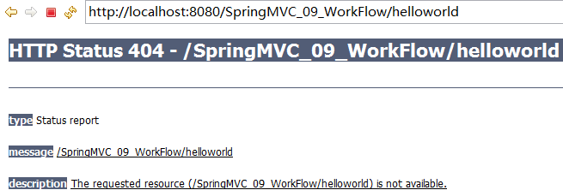

Debug流程分析
- HandlerExecutionChain mappedHandler；包含了拦截器和处理器方法；
DispatcherServlet L902 916
org.springframework.web.servlet.HandlerExecutionChain
Handler execution chain, consisting of handler object and any handler interceptors. Returned by
HandlerMapping's HandlerMapping.getHandler method.
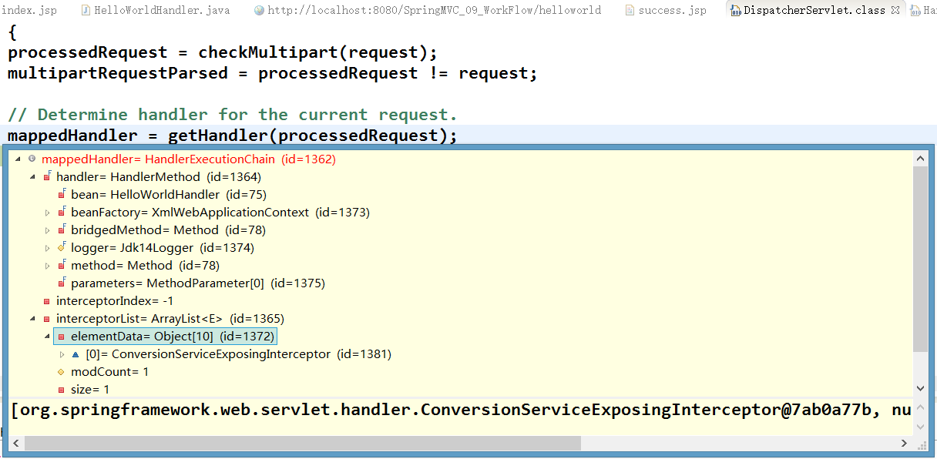
- HandlerMapping
org.springframework.web.servlet.HandlerMapping
Interface to be implemented by objects that define a mapping between requests and handler objects.
This class can be implemented by application developers, although this is not necessary, as org.springframework.web.servlet.handler.BeanNameUrlHandlerMapping and org.springframework.web.servlet.handler.SimpleUrlHandlerMapping are included in the framework. The former is the default if no HandlerMapping bean is registered in the application context.
HandlerMapping implementations can support mapped interceptors but do not have to. A handler will always be wrapped in a HandlerExecutionChain instance, optionally accompanied by some HandlerInterceptor instances. The DispatcherServlet will first call each HandlerInterceptor's preHandle method in the given order, finally invoking the handler itself if all preHandle methods have returned true.
The ability to parameterize this mapping is a powerful and unusual capability of this MVC framework. For example, it is possible to write a custom mapping based on session state, cookie state or many other variables. No other MVC framework seems to be equally flexible.
Note: Implementations can implement the org.springframework.core.Ordered interface to be able to specify a sorting order and thus a priority for getting applied by DispatcherServlet. Non-Ordered instances get treated as lowest priority.
- 没有配置<mvc:default-servlet-handler/>，<mvc:annotation-driven/>,发送一个不存在资源的请求路径，mappedHandler为null
- http://localhost:8080/SpringMVC_09_WorkFlow/helloworld2
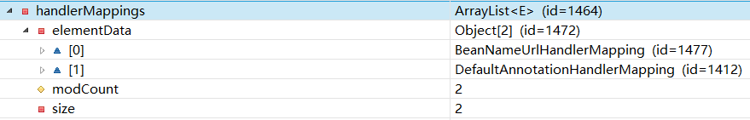

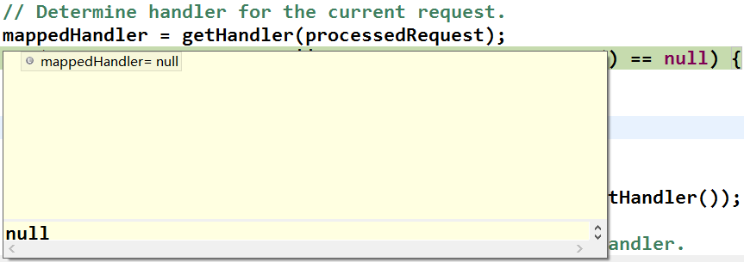
- 配置<mvc:default-servlet-handler/>，<mvc:annotation-driven/>,发送一个不存在资源的请求路径
- http://localhost:8080/SpringMVC_09_WorkFlow/helloworld2
- mappedHandler不为null,原因是当循环simpleUrlHandlerMapping时，当做静态资源处理
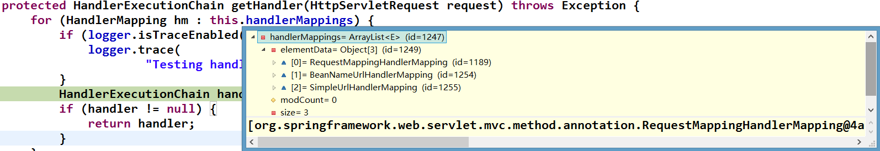

断点
